Module name :Log-in/registration of UI/UX test
Test case ID:ST_01
Webpage URL: www.automationexercise

Scenario ID : 1a

Scenario:Valid registration
Test steps:

1.click on Log-in
2.Enter details in all filled
3.click on sign-up
4.again filled your other information

Screenshot:

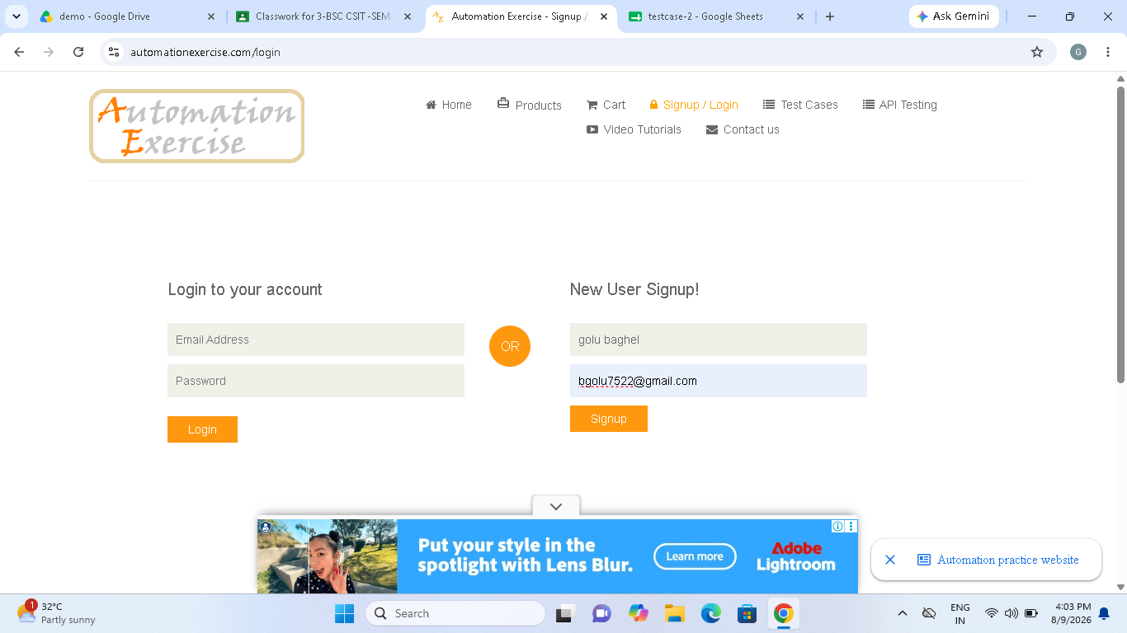

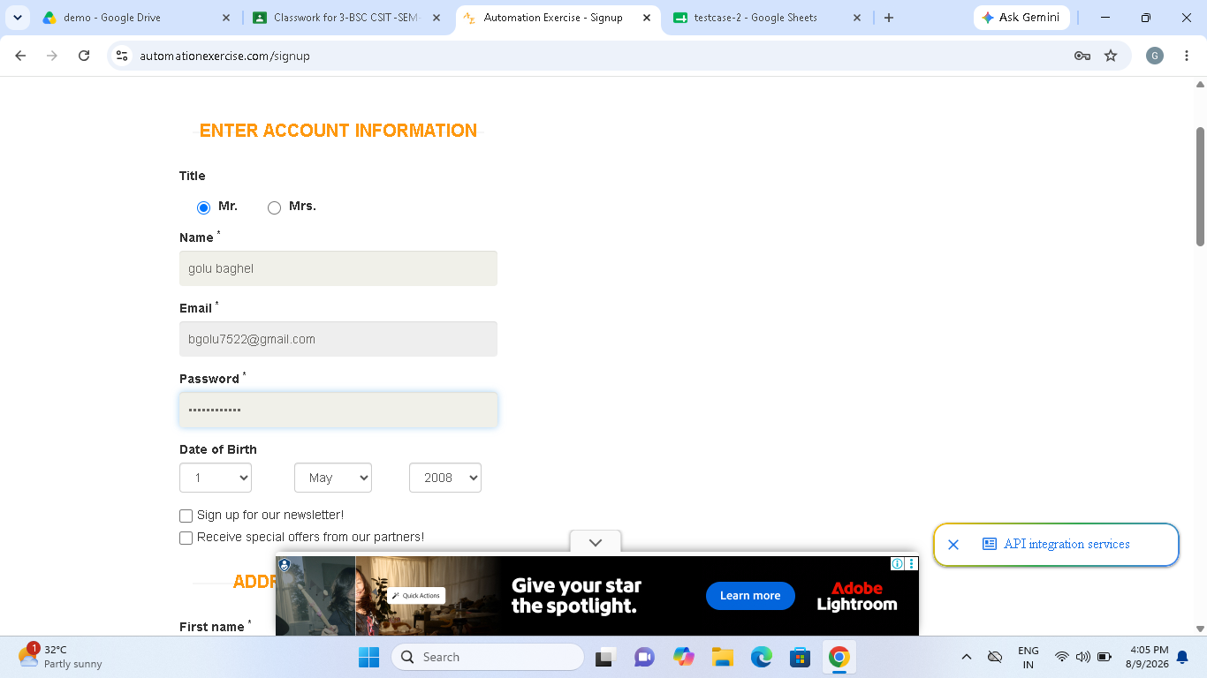

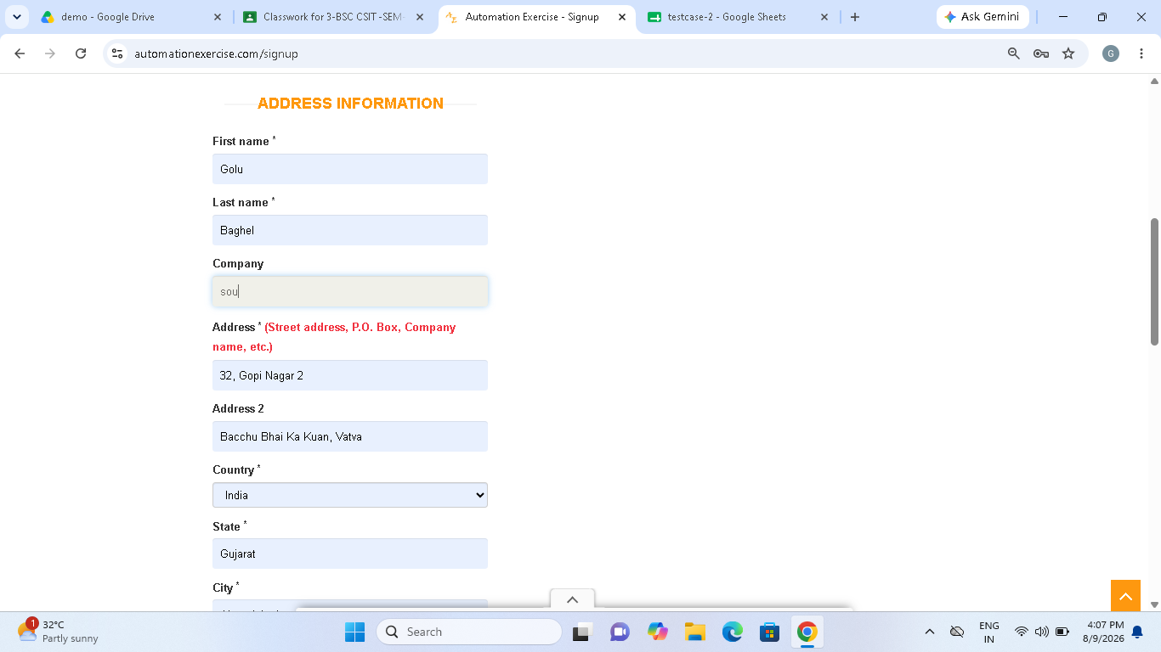

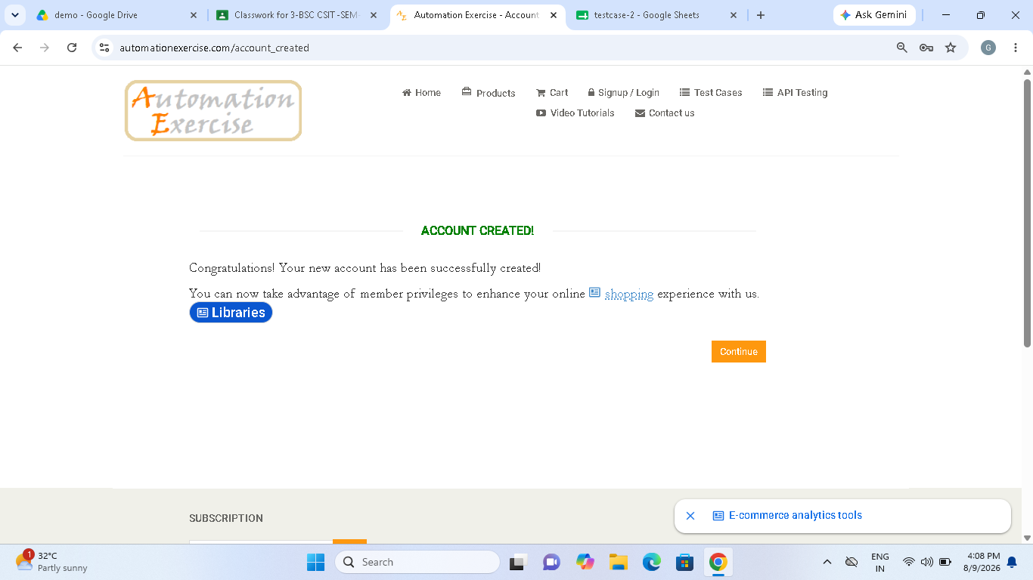

Scenario ID : 1b

Scenario:Invalid registration
Test steps:

1.click on sign up
2.fill Invalid details in all filled
3.click on sign-up

Screenshot:

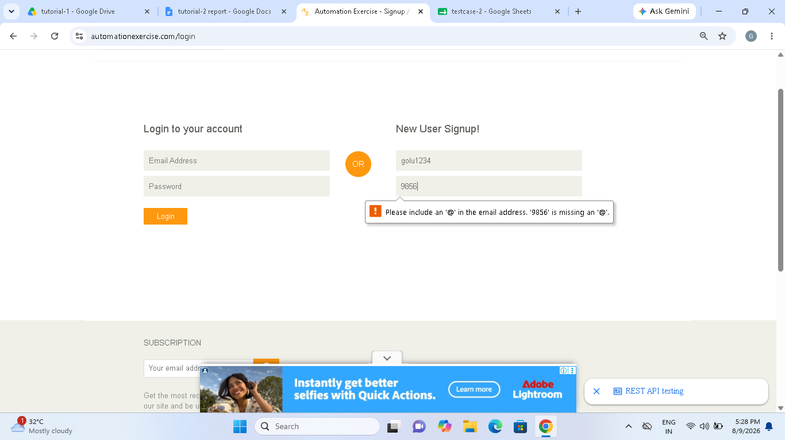

Scenario ID : 1c

Scenario: Existing email registration
Test steps:
1.fill details in log-n to your account domain
2.click on log-in

Screenshot:

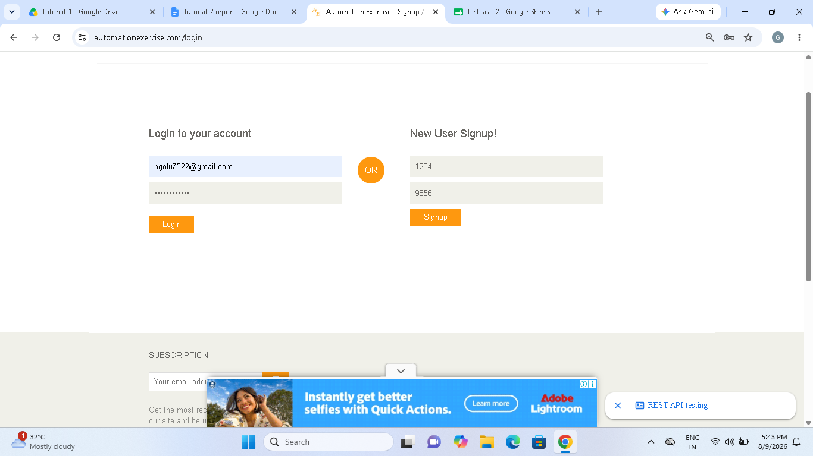

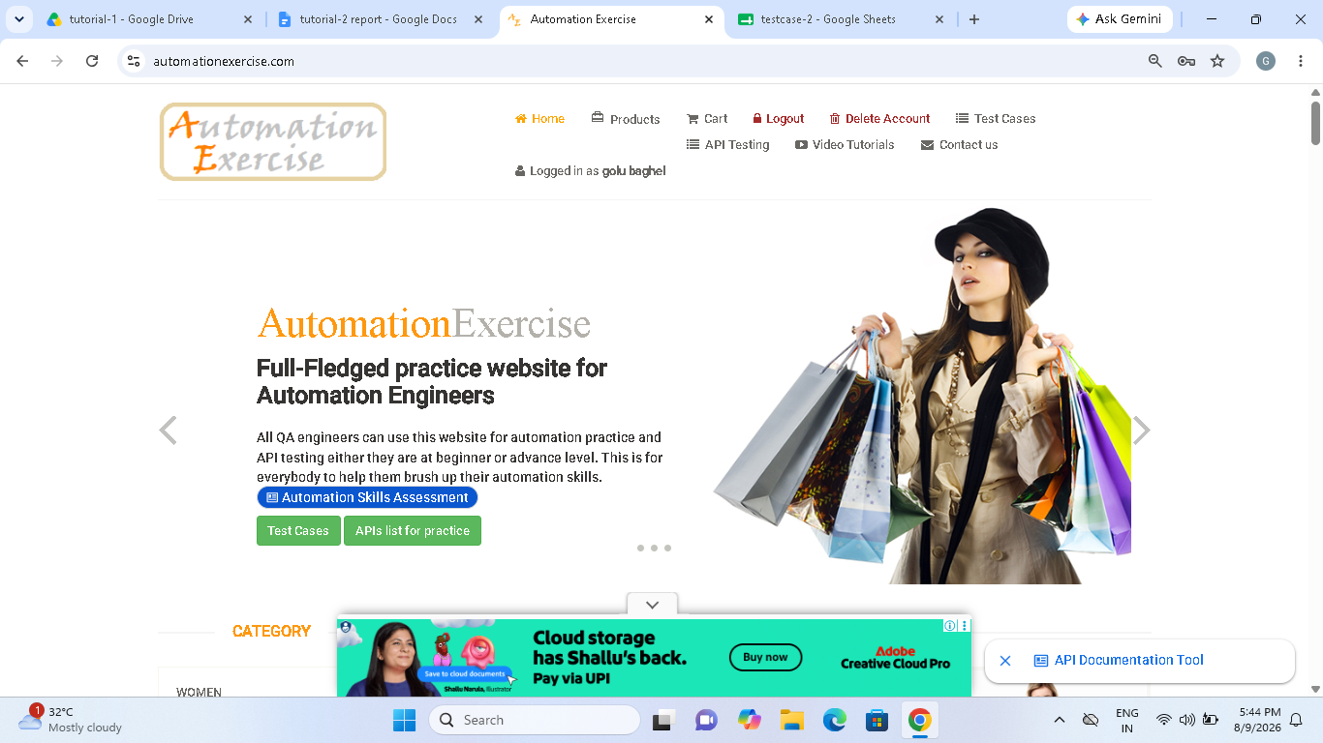

Scenario ID : 1d

Scenario: Valid login
Test steps:
1.click on Log-in
2.Enter valid email id and password
3.click on log-in

Screenshots:

Scenario ID : 1e

Scenario: Invalid email
Test steps:
1.click on Log-in
2.Enter invalid email id and password
3.click on log-in

Screenshots:

Scenario ID : 1f
Scenario: Invalid password
Test steps:
1.click on Log-in
2.Enter invalid email id and password
3.click on log-in

Screenshots:

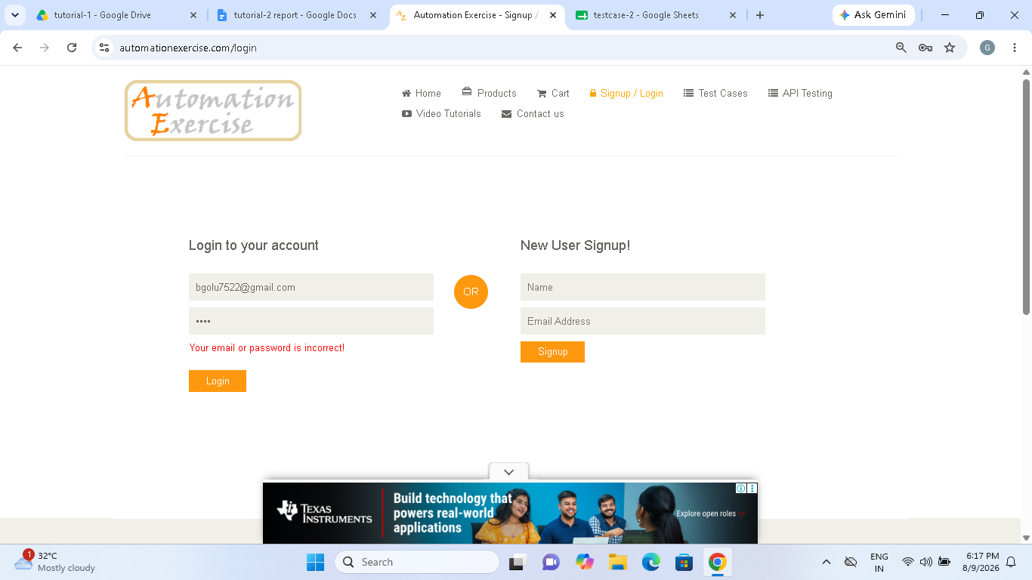

Scenario ID : 1g
Scenario: blank username
Test steps:
1.click on log-in
2.do not write username
3.enter email
4.click on log-in

Screenshots:

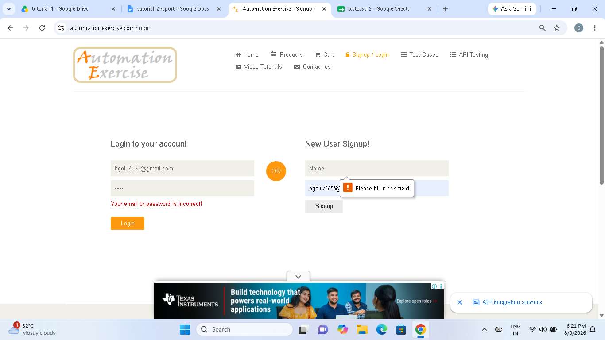

Scenario ID : 2a
Scenario: Log-out
Test steps:
1.click on log-out
Screenshot:

